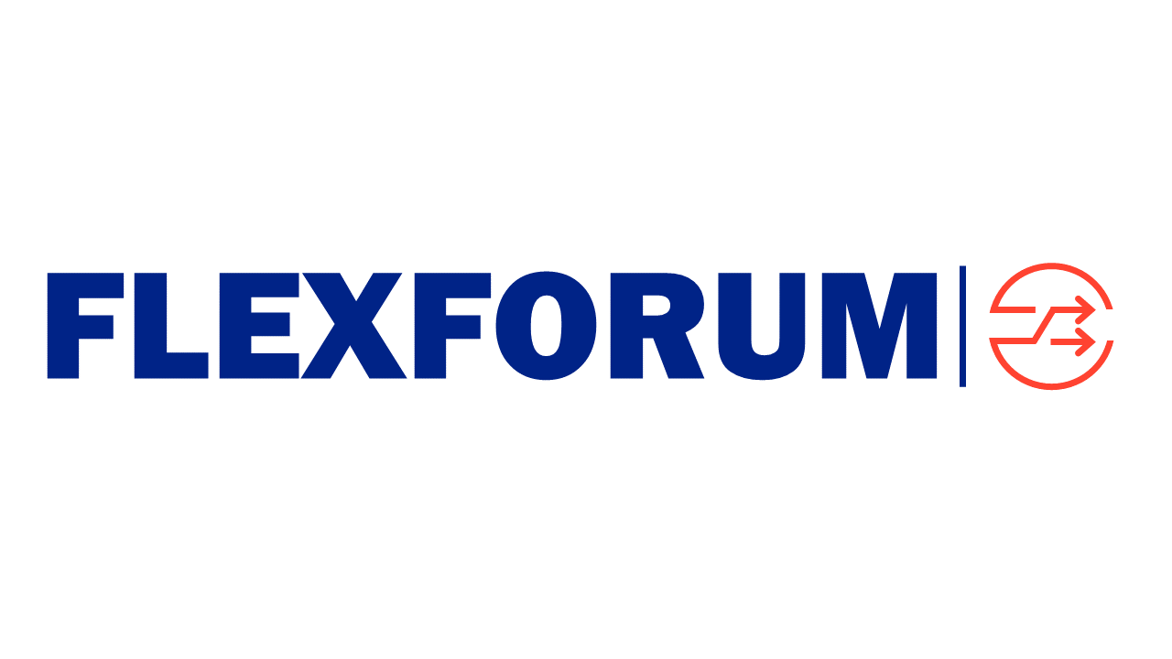

Steering Group meeting

When | Thursday 4 April 2024, 0930-1200
Where | Virtual
Who | Steve Batstone, Shay Brazier, John Campbell, Ryan Kuggeleijn, Matt Smith, Evie Trolove, Fiona Wiseman  Secretariat: Craig Evans  Observers: Briony Bennett (Ara Ake), Sean McCready (CC)
Apologies | Terry Paddy, Mark Herring (EA), Peter Bartlett (MBIE), Brian FitzGerald (EECA)

Session notes
1: Welcome
The Chair welcomed everyone to the session.
The SG:
- confirmed there was a quorum
- noted their individual obligations relating to the Commerce Act 1986 prohibiting anti-competitive conduct
- noted the reminder to review and update interests
- noted apologies
- confirmed the agenda, including discussion of 2 items of other business
  - process for FF to decide whether to respond to a regulatory consultation or otherwise decides to provide a FF perspective on an issue
  - timing of the AGM.
Strategic items
2: Objectives and key results
The SG discussed setting objectives and key results to focus efforts and keep them aligned with the FlexForum objective and purpose.
The SG agreed to refine the draft objectives and key results to reflect what matters, to be controllable (by FlexForum and the Steering Group) and to align with the constitution where relevant (eg, approval thresholds).
The discussion covered
- Context and background. The draft objectives emerged from the November 2023 discussion about things the SG specifically could do to achieve the principles expressed in the Flexibility Plan (accountability etc) and to align with the constitution. There are two types of objectives:
  - engagement and communications
  - assurance about the type and quality of activities, and always keeping these focused on practical outcomes and direct impact on humans
- The objectives were generally supported. Comments included:
  - leadership. There are lots of conversations occurring, but a FF point of difference is it is actively trying to lead and guide conversation and contribute to regulatory conversations, particularly providing technical expertise which regulators do not have. Proactive engagement with regulators before consultation papers is written is valuable – responding to papers is often too late. But FF needs to be doing certain things to earn and maintain the credibility to be seen as a leader
  - measuring results will be difficult for some things, eg, making it easier for humans, because how do we know things are easier. But still needs to be done.
  - Measure a small number of meaningful things using a ‘do what’ and ‘for who’ approach
  - Recognise that many things are outside SG and FF control. As such, FF may be limited to highlighting how FF has enabled or contributed to a change.
3: A 3 year endeavour
The SG discussed the opportunities and implications of setting a 3 year lifespan for FlexForum as a way to think about what and how would be done to have the greatest impact.
The SG requested that a 3-year plan be articulated to use in conversations with Members and partners about how FF can add value in the short and medium term.
Being able to describe outputs and achievements to be delivered in the next 3 years is better than presenting a long list of tasks requiring a decade of effort.
The approach aligns with a start-up approach – year 1 is foundational, year 2 is preparation, and year 3 is implementing the minimum viable product in market. FF could ask itself – what would be implemented in year 3? And then work backwards to identify what testing etc is needed to get to the MVP.
The 3-year cycle has parallels with the Ofgem Strategic Innovation Fund. Each stage should be demonstrating value while building momentum.
Standing items
4: Engagement update
The SG noted the completed and planned engagement activity.
- the Parliamentary Commissioner for the Environment and Infrastructure Commission want a briefing and conversation about the workplan
- conversations are being arranged with prospective Members.
5: Workplan update
The SG noted the workplan update.
- the workplan tracker and reporting framework is a work in progress and will be further refined. The SG requested creation of a single task and activity reporting tracker including workplan tasks, funding agreement deliverables and other activities
- the funding agreement deliverables are on track. The next key deliverable is the engagement plan due 31 May
- EECA has asked if FF could undertake a new workplan task to provide advice about assisting businesses with energy intensive activities that could be decarbonised with information/tools they can use to explore the full potential of flexibility offerings, including quantifying additional financial (capital or operational) and non-financial benefits available from flexibility. The SG requested more information about the scope of the proposed task to help it understand the implications for FF, including how FF gets value from the exercise.
  - the FF value add over a traditional consultant is obtaining and facilitating diverse opinions
  - more information about the purpose and objective of the project is needed to understand if it is a core FF activity and if there is risk/liability issues
  - an output something like this Energy UK Connecting your Fleet guide for commercial flexibility could be useful.
6: Finance update
The SG noted the finance update.
Procedural items
7: Membership requests
The SG noted Basis asked to join FlexForum on 2 April 2024.
8: Actions
The SG noted the status of actions from previous sessions.
9: Next Steering Group meeting
The SG agreed to reschedule its monthly meeting to the 2nd Thursday of each month starting 9 May.
10: Any other business
The SG discussed two items of other business.
- A process for FF to decide whether to respond to a regulatory consultation or otherwise decides to provide a FF perspective on an issue. The SG agreed principles are required to decide whether to allocate resources to a consultation or to provide advice, including that the process should be initiated by Members
- timing of the AGM. The SG noted the AGM is flagged for August in the Incorporated Societies Register but can be at another time so long as it is within 6 months of the 30 March 2024. The AGM is a key date because that is when the workplan and budget must be approved by Members, and this will influence subscriptions and invoicing

Finish 12.02

