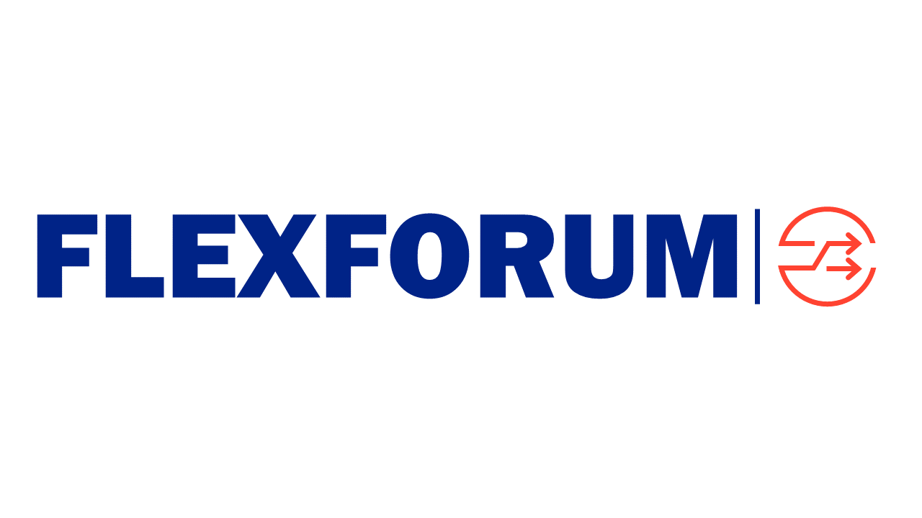

Steering Group meeting

When | Thursday 7 March 2024, 0930-1200
Where | Virtual
Who | Steve Batstone, Shay Brazier [after 1030], John Campbell, Terry Paddy, Matt Smith, Evie Trolove, Fiona Wiseman  Secretariat: Craig Evans  Observers: Mark Herring (EA), Peter Bartlett (MBIE), Briony Bennett (Ara Ake) Cristiano Marantes (Ara Ake), Sean McCready (CC)
Apologies | Ryan Kuggeleign, Brian FitzGerald (EECA)
Session notes
1: Welcome
The Chair welcomed everyone to the session.
The SG:
- confirmed there was a quorum
- noted their individual obligations relating to the Commerce Act 1986 prohibiting anti-competitive conduct
- noted the reminder to review and update interests
- noted apologies
- confirmed the agenda, including discussion of other business
  - membership communication
  - update on processes and systems
  - timing of further discussion of organisation key outcomes and results measures.
Strategic items
2: Workplan story
The SG discussed the meta outputs of the 2024 workplan and what we want people to know, feel and do when describing the workplan.
- the workplan includes both workstream tasks and broader FlexForum tasks, eg, updating the Flexibility Plan
- we are building our understanding of related work, eg, by the Future Networks Forum, EECA and the EA. Building a complete picture is difficult for a range of reasons. From an outsiders perspective, it may look like duplication of activity. Sharing of detailed information outlining the start, middle and end of a process/and state of thinking will improve coordination. The SG noted that transparency of activity and thinking will save everyone time, effort and costs.
- a discussion between FF stream conveners and FNF stream leads is being planned to delve into the details of respective activities and timeframes to identify opportunities for effective alignment.
- FF will continue to encourage transparency of activity and thinking and will walk this talk by publishing workplan and workstream materials (via the Knowledge Hub, once it is established).
- the SG agreed the workplan story effectively represented intention of the workplan and aligns with the FlexForum objective and purpose, while noting the story would evolve over time.
  - the immediate audience is Members and the electricity ecosystem, particularly decision-makers. The workplan will produce content which can be shared with households, businesses and communities.
- the workplan (and a key message for the story) will help to articulate what is a consumer-centric market and system which can become the reference point for decision-makers across the electricity ecosystem when they are making decisions about upgrading regulatory settings. There is real value for decision-makers in having practical exemplars of household/business/community energy (and flexibility) outcomes.
  - recognising that the exemplars will be reference points, not commitments, and the future state is many cases is some time off
  - the exemplars will provide a framework to consider the implications of more detailed customer segmentation exercises, eg, being undertaken by the FNF, and to consider implications for energy equity and justice
  - having practically based exemplars will enable reality testing of the outcomes that are plausible for different people in different places, ie, they enable FF to validate and tell a coherent story
- the workplan outputs appear to align with regulatory expectations that industry players are acting and investing based on what people want. The existing regulatory framework for network operators drives a network-centric approach that does not capture impacts/benefits across the ecosystem. Given this there is a strong value proposition of having a whole of system view of outcomes and underlying market/system arrangements from the plug/to the plug.
3: Workstream participation
The SG discussed ways to achieve productive and effective workstream participation, noting that
- what we produce is only as good as the expert input
- but does require commitment as delivering the workplan tasks will involve 2-3 workshops a month from March to July, plus targeted check in sessions with key experts.
As an initial step, a FlexForum session is being arranged for late March. It will have 2 parts:
- for Members: to update Members on the workplan and the importance of Member participation
- for all comers: to describe and discuss the workplan outputs and how these fit into the bigger picture (ie, the workplan story).
The SG suggested the session (and generally) be used to provide existing and new Members an opportunity to check in on ways of working, participation options etc.
Standing items
4: Engagement update
The SG noted the completed and planned engagement activity.
- FlexForum has communicated to the Electricity Sector Framework its basis of engagement/participation. A new version of the Framework document is expected in the coming weeks
- the session with Simeon Brown was positive. Based on the discussion, a follow-up session will be requested
- Downstream attendance enabled positive interactions with Electricity Authority staff/members, existing FlexForum Members, and potential Members
5: Workplan update
The SG noted the workplan update and agreed the 2024 workplan should begin to be delivered based on the proposed programme and delivery schedule.
- the workplan tasks align with the FlexForum objective and purpose and the Flexibility Plan
- each task is on the FlexForum workplan and the extra task requested by EECA meets a specific FlexForum purpose to provide advice to regulators. The addition of the EECA task will be included in an update to Members about the workplan and delivery schedule
- workstreams and workstream conveners (individually and collectively) are satisfied with the task plans and delivery schedule
- the resourcing envelope is sufficient to deliver the initial set of tasks.
  - the SG requested a breakdown of the resource cost per task and stream
  - the SG noted workstream conveners will provide visibility of activities and work to avoid inadvertent scope creep and resource shortfalls. The conveners will be supported to provide monthly status reports to the SG and Members.
The SG noted progress with the deliverables listed in the funding agreement.
6: Finance update
The SG noted the finance update.
Procedural items
7: Membership requests
The SG noted Rewiring Aotearoa joined FlexForum during February 2024 and another party had requested information about joining.
8: Actions
The SG noted the status of actions from previous sessions.
9: Next Steering Group meeting
The SG confirmed its next meeting is 0930-1200 4 April 2024.
A FlexForum meeting will be scheduled for 26 or 27 March.
10: Any other business
The SG discussed four items of other business.
- membership communication - regular sharing information with Members will support active participation. Kicking off the workplan will result in a higher tempo of Member communication
- update on processes and systems - documenting ways of working will make it easier for people to get involved and standardise practises. This activity will be undertaken by the administration resource.
- timing of further discussion of organisation key outcomes and results measures. This discussion will be included as a strategic item at an upcoming meeting
- FlexForum submissions - specifically, is FF looking at a response to EA Future System Operation consultation? Generally, how does FlexForum decide to respond to a consultation. The SG noted the intention to ask Members this question.

Finish 1203

